LAB EXPERIMENT RECORD
SET 9: Online Learning Activity Analysis
Department | AI&DS
Course Code / Course Name | DSA0602 / Data Handling and Visualization
Experiment | Data Visualization using R
Name | DEVAMADA HEMASREE
Register Number | 192524114
Date | 03 OCTOBER 2026
Day | saturday
SET 9: Online Learning Activity Analysis
Aim: To analyze online learning data using a histogram, boxplot, bubble scatter plot, and monthly trend line chart in R, and to build an interactive dashboard using Tableau.
Student_ID | Gender | Age | Course | Study_Time (hrs) | Videos_Watched | Quiz_Score | Login_Date
L01 | Male | 20 | R | 3.5 | 12 | 78 | 2025-01-05
L02 | Female | 22 | R | 4.2 | 15 | 85 | 2025-01-05
L03 | Male | 19 | SQL | 2.0 | 8 | 65 | 2025-02-08
L04 | Female | 21 | R | 5.0 | 18 | 92 | 2025-02-08
L05 | Male | 23 | R | 2.5 | 9 | 70 | 2025-03-12
L06 | Female | 20 | SQL | 4.0 | 14 | 88 | 2025-03-12
PROGRAM 1: Histogram and Boxplot (Quiz Score)
Aim: To import the dataset, plot a histogram of Quiz_Score, and draw a boxplot of Quiz_Score by Course.
df <- data.frame(
Student_ID = c("L01", "L02", "L03", "L04", "L05", "L06"),
Gender = c("Male", "Female", "Male", "Female", "Male", "Female"),
Age = c(20, 22, 19, 21, 23, 20),
Course = c("R", "R", "SQL", "R", "R", "SQL"),
Study_Time = c(3.5, 4.2, 2.0, 5.0, 2.5, 4.0),
Videos_Watched = c(12, 15, 8, 18, 9, 14),
Quiz_Score = c(78, 85, 65, 92, 70, 88),
Login_Date = c("2025-01-05", "2025-01-05", "2025-02-08",
"2025-02-08", "2025-03-12", "2025-03-12")
)
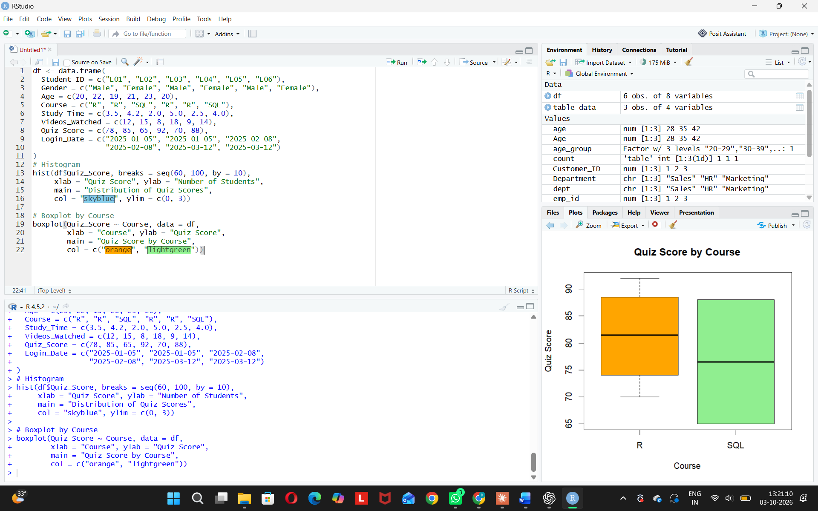
Interpretation:
- Most students score between 65 and 90.
- R students perform better (average 81.25) than SQL students (average 76.5).
- R scores are more spread out (70 to 92).

PROGRAM 2: Bubble Scatter Plot (Study Time vs Quiz Score)
Aim: To study the relationship between study time and quiz score, with bubble size showing videos watched.
graphics.off()
Study_Time <- c(3.5, 4.2, 2.0, 5.0, 2.5, 4.0)
Videos_Watched <- c(12, 15, 8, 18, 9, 14)
Quiz_Score <- c(78, 85, 65, 92, 70, 88)

plot(Study_Time, Quiz_Score,
cex = Videos_Watched / 5,
pch = 19, col = rgb(0, 0, 1, 0.5),
xlab = "Study Time (hrs)", ylab = "Quiz Score",
main = "Study Time vs Quiz Score",
xlim = c(1.5, 5.5), ylim = c(60, 100))

cor(Study_Time, Quiz_Score)
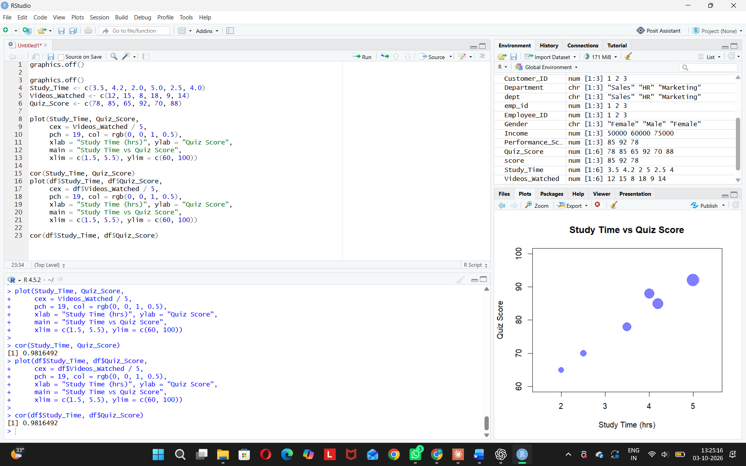
PROGRAM 3: Monthly Average Quiz Score (Line Chart with Moving Average)
Aim: To convert Login_Date into Date format, find the monthly average quiz score, and plot it with moving average smoothing.
graphics.off()

df <- data.frame(
Student_ID = c("L01", "L02", "L03", "L04", "L05", "L06"),
Quiz_Score = c(78, 85, 65, 92, 70, 88),
Login_Date = c("2025-01-05", "2025-01-05", "2025-02-08",
"2025-02-08", "2025-03-12", "2025-03-12")
)

df$Login_Date <- as.Date(df$Login_Date)
df$Month <- format(df$Login_Date, "%Y-%m")

monthly <- aggregate(Quiz_Score ~ Month, data = df, FUN = mean)
print(monthly)

ma <- stats::filter(monthly$Quiz_Score, rep(1/2, 2), sides = 1)

plot(1:3, monthly$Quiz_Score, type = "o", col = "blue", pch = 19,
xaxt = "n", ylim = c(75, 85),
xlab = "Month", ylab = "Average Quiz Score",
main = "Monthly Average Quiz Score")
axis(1, at = 1:3, labels = monthly$Month)
lines(1:3, ma, col = "red", lwd = 2, lty = 2)

legend("topright",
legend = c("Monthly Average", "Moving Average"),
col = c("blue", "red"), lty = c(1, 2), pch = c(19, NA))

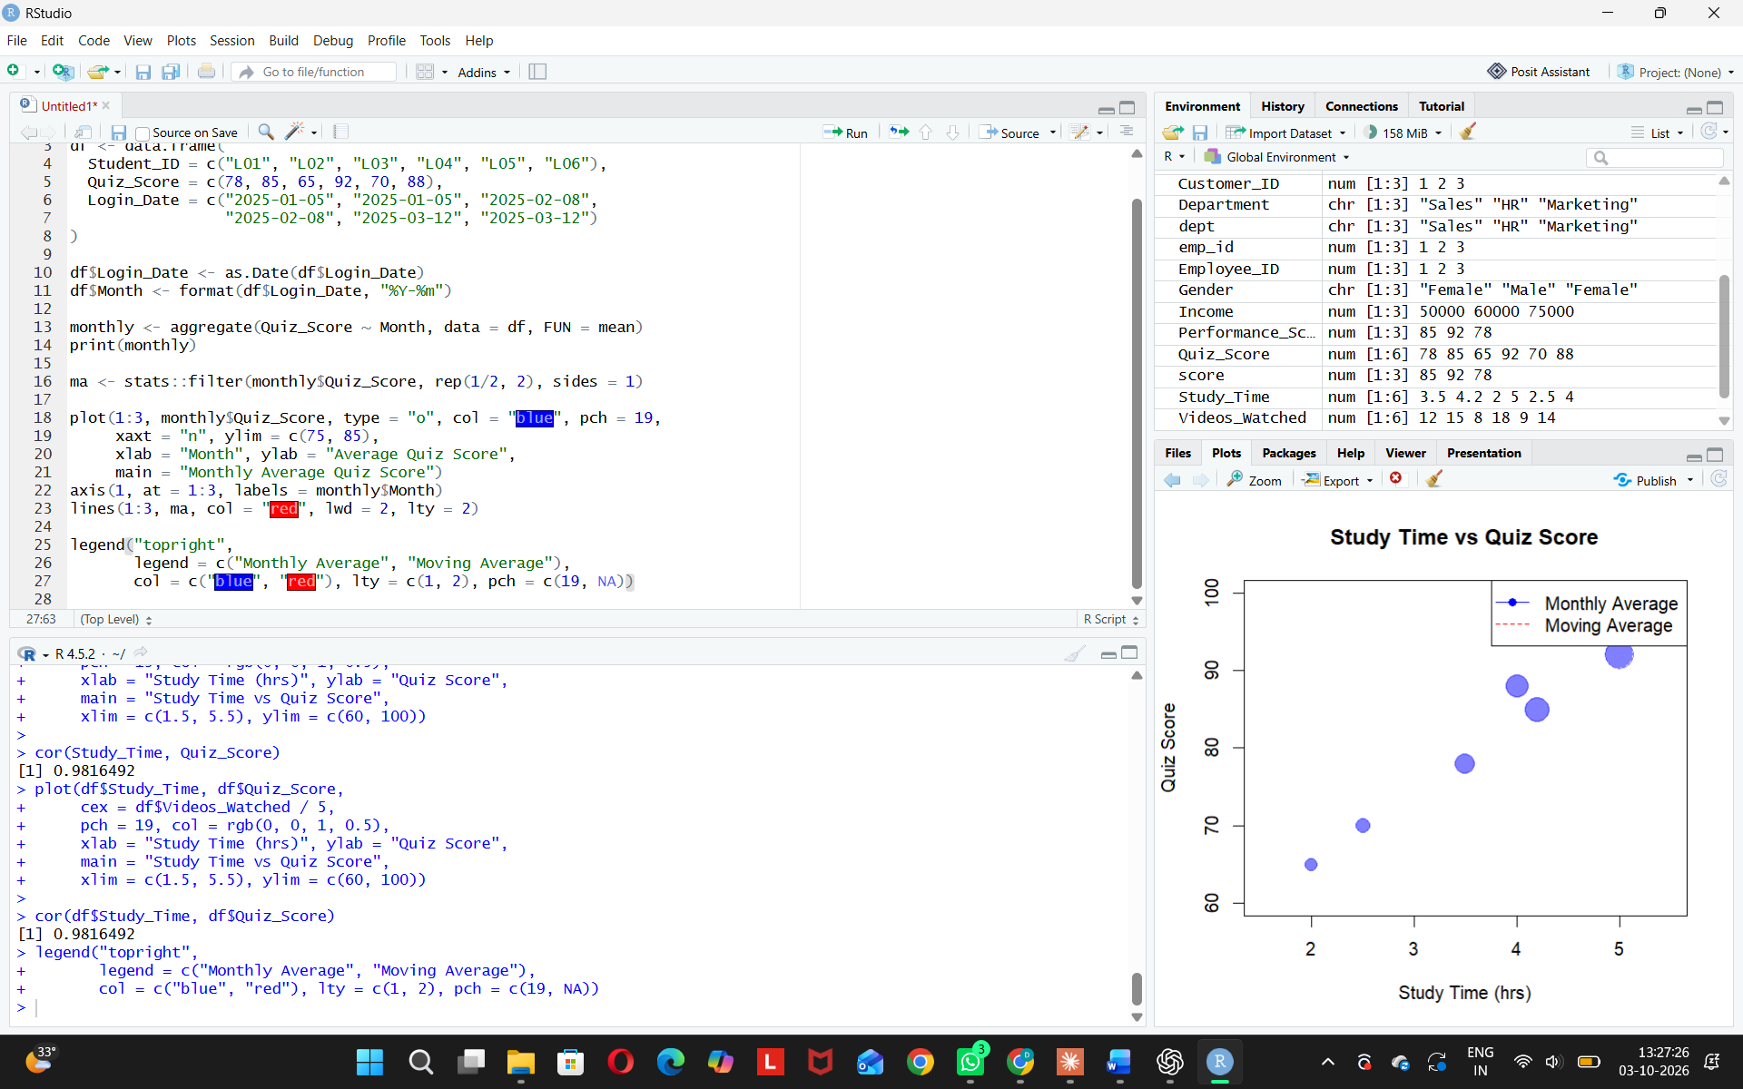
OUTPUT:
- Blue line with dots: 81.5 → 78.5 → 79.0.
- Red dashed line (moving average) starts from February: 80.0 → 78.75.
- Legend in the top-right corner.
Trend:
- Average score drops from January to February.
- It rises very slightly in March.
- Overall trend is slightly downward but almost stable.
PROGRAM 36: Tableau Dashboard
- Aim: To build a mini interactive dashboard with a bar chart, scatter plot, and filters in Tableau.
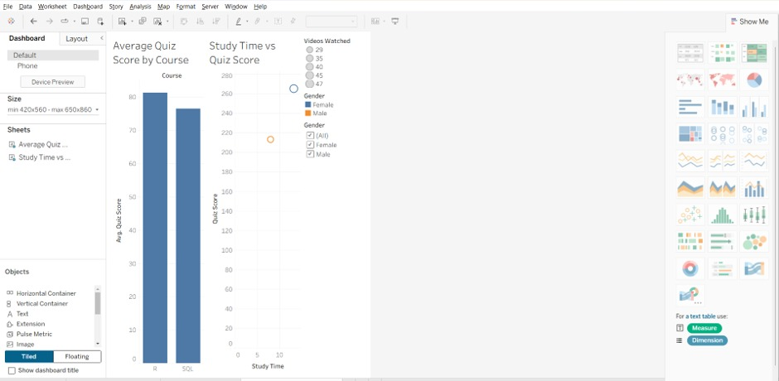
Observation: The user can explore quiz performance by course and gender interactively.

